PakCFacts
Computer Hardware Identification and Repair Guide
A Computer Systems Servicing (CSS) Capstone Project Research Paper
A Capstone Project Presented to Ma’am Kaye
In Partial Fulfillment of the Requirements for Computer Systems Servicing
Grade 12 – ICT / CSS
Submitted by:
Arnold Gelacio
John Paul Arroyo
Colleen Caranglan
Mhart Yuri Molo
Claire Deloyas

October 2026

Abstract
PakCFacts is a learning website which aims to educate beginners about computer hardware, their operations, and also offers tips on troubleshooting and safety related to hardware. This website was developed using HTML, CSS, and JavaScript and comprises six pages namely: Home Page, Hardware Identification, Hardware Functionality and Compatibility, Hardware Troubleshooting, Hardware Diagnosis, and Maintenance and Safety.The current source code includes a catalog of twelve components, eight troubleshooting guides, a decision-tree tool with eight questions and twelve possible result screens, and a ten-task maintenance checklist that stores progress in the browser. This paper introduces the project and reviews related sources on Computer Systems Servicing education in the Philippines, safe handling of electronic components, hardware diagnosis, usability, accessibility, and responsive web design.

Table of Contents
Contents
Abstract 2
Table of Contents 3
Chapter 1 3
1.1 Background of the Study 3
1.2 Statement of the Problem 4
1.3 Objectives of the Study 4
1.4 Significance of the Study 5
1.5 Scope and Limitations 5
Table 1.1 Implementation Status of Website Features 6
CHAPTER 2 7
2.1 Computer Systems Servicing Education in the Philippines 7
2.2 Safe Handling and Preventive Care of Hardware 7
2.3 Computer Hardware Diagnosis and Troubleshooting Systems 8
2.4 Usability and Accessibility 8
2.5 Responsive Web Design and Web Technologies 9
2.6 Synthesis 9
CHAPTER 3 11
3.1 Research and Development Design 11
3.2 Development Tools and Technologies 11
3.3 System Development Process 11
3.4 Description of the System 12
3.5 Testing Procedure 12
3.6 Data Gathering and Evaluation 13
3.7 Ethical and Safety Considerations 13
CHAPTER 4 14
4.1 Implementation of the Website 14
4.2 Results of Functional Testing 14
Table 4.2. Summary of Functional Testing 16
4.3 Results of Responsive Layout Testing 16
Table 4.3. Responsive Layout Testing 16
4.4 Debugging and Error Correction 17
Table 4.4. Debugging Record 17
4.5 Discussion of Findings 17
CHAPTER 5 18
5.1 Summary 18
5.2 Conclusions 18
5.3 Recommendations 19
5.4 Final Recommendation 19
Appendices 19
Appendix A — Website Screenshots 19
Appendix B — Source Code 21
References 21

Chapter 1
Introduction

1.1 Background of the Study
Computers Systems Servicing is one of the important courses in technical-vocational education in the Philippines. As noted by the Technical Education and Skills Development Authority (TESDA, 2013), CSS NC II covers skills like installation and configuration of computer systems, network and server set up, maintenance and repairs of computer systems and networks. The ICT specialized subject on CSS NC II from DepEd curriculum guide includes among the expected competencies knowledge about assembly of computer hardware, maintenance, identification of problems, corrections of flaws, and testing of whether the repaired system functions correctly (DepEd, 2016). From the listed skills, it becomes clear that students should know how to identify hardware components and troubleshoot.
Safe handling is yet another aspect of computer servicing. According to IBM (n.d.), components with transistors or integrated circuits can be harmed due to electrostatic discharge, defined as a “sudden flow of static electricity.” In line with this, the recommendations of Supermicro (n.d.) concerning motherboards include wearing a wrist strap that is grounded, gripping boards by their edges, and keeping components in anti-static bags. Identification of hardware is just one of the aspects of servicing; safe handling of components is equally important.
For beginners, identifying a component and understanding its purpose can be difficult, especially when several parts work together inside one computer. It can also be hard to decide which checks are safe to try when a computer develops a problem. PakCFacts was created to bring basic hardware identification, compatibility information, troubleshooting guidance, and maintenance and safety advice together in one website. The goal is to make these topics easier to find and understand.

1.2 Statement of the Problem
The scope of the current project is concerned with the ways to present hardware information, some troubleshooting tips and safety instructions related to computer maintenance using HTML, CSS and basic JavaScript on a website.
The following questions are addressed in this project:
- How can information about common computer hardware components be organized so beginners can search for and identify them?
- How can the website explain the functions of major components and introduce basic compatibility considerations?
- How can the website present clear, step-by-step guidance for common hardware problems?
- How can a simple decision tree guide users toward possible causes and safe next steps?
- How can the website present computer maintenance and safety information, including a checklist?

1.3 Objectives of the Study
General objective. To develop PakCFacts as an educational website for computer hardware identification, basic troubleshooting, and safe maintenance.
Specific objectives. The project aims to:
- Create a searchable hardware catalog covering twelve components, including their functions, locations, working principles, common signs of failure, basic troubleshooting, and relevant compatibility and handling notes.
- Explain the functions of major computer components and introduce basic compatibility considerations on a dedicated page.
- Provide eight troubleshooting guides that describe symptoms, possible causes, safe initial checks, suggested steps, expected observations, and when to seek help from a technician.
- Develop an interactive hardware diagnosis feature using a JavaScript decision tree.
- Provide a maintenance and safety page with a ten-task checklist and a progress indicator.
- Evaluate the website through at least twenty documented functional and responsive-layout test cases and record the actual results.

1.4 Significance of the Study
PakCFacts is intended to serve as a supplementary learning resource. Its possible benefits depend on how users make use of the information; the group has not yet conducted a user evaluation.
- CSS students may use the website to review component names, functions, and safe handling practices.
- Beginner computer users may consult the troubleshooting guides to learn about basic checks that can be performed safely.
- Teachers and instructors may use selected pages as additional material when discussing hardware and maintenance.
- People learning basic computer care may use the maintenance checklist as a reminder of routine tasks and safety precautions.
- Future student developers may refer to the project as a simple example of a website built with HTML, CSS, and JavaScript.

1.5 Scope and Limitations
Scope. PakCFacts is designed for students and beginner computer users. The current project includes six website pages, information on twelve desktop-computer components, eight troubleshooting guides, and a decision-tree diagnosis tool. The source files reviewed for this draft use HTML, CSS, and JavaScript without external libraries or frameworks. The website does not use a server or database. The maintenance checklist stores its progress in the browser’s localStorage.
Limitations. The project has the following limitations:
- The website provides educational information and is not a substitute for professional repair services.
- Diagnosis results suggest possible causes; they do not confirm the exact cause of a hardware problem.
- The website does not connect to a computer or inspect its physical hardware automatically.
- Compatibility information is general and may not cover every component model or configuration.
- Checklist progress is stored in the browser on the current device. It may be lost if browser data is cleared and does not automatically transfer to another device.

Table 1.1 Implementation Status of Website Features
Website feature | Status based on source review | Notes
Home page and navigation | Implemented and functional | The home page loads correctly, and navigation links direct users to the intended sections.
Hardware Identification | Partially implemented | The component catalog displays hardware names and functions. Search and category filtering return the expected results.
Hardware images | Not found as image files | Emoji icons and an SVG diagram are present. Actual hardware images may be added to improve visual identification.
Hardware Functions and Compatibility | Implemented and functional | The page displays component functions, two comparison tables, and a compatibility checklist.
Hardware Troubleshooting | Implemented and functional | Eight troubleshooting guides are displayed with symptoms, possible causes, and recommended initial checks.
Interactive Hardware Diagnosis | Implemented and functional | The decision tree presents eight questions and directs users to the appropriate result screen based on their answers.
Maintenance and Safety | Implemented and functional | The ten-task maintenance checklist allows users to mark tasks and view their progress.
Responsive layout | Implemented and functional | The layout adjusts to different screen sizes, including mobile-sized screens.

CHAPTER 2
Review of Related Literature and Studies
This chapter reviews materials related to the skills and design choices behind PakCFacts. The topics include Computer Systems Servicing education in the Philippines, safe handling of hardware, computer diagnosis, usability and accessibility, and responsive web design. However, each topic is discussed within the context of the website, but any results already obtained in published literature are not mixed up with those which the team has developed. There is some additional information that should be cross-checked with the original sources.

2.1 Computer Systems Servicing Education in the Philippines
TESDA’s (2013) training regulations describe Computer Systems Servicing NC II through competencies that include installing and configuring computer systems, setting up networks and servers, and maintaining and repairing computer systems and networks. The regulations also refer to occupational health and safety, although the exact wording should be checked against the official document. The Department of Education’s curriculum guide for the senior high school ICT specialization presents related learning outcomes, including system maintenance, fault diagnosis, correction of defects, and testing after repair (DepEd, 2016). These documents provide the Philippine educational context for PakCFacts. These areas covered on the site are related to what students learn in CSS, including part identification, functioning, problem-solving, and safe maintenance procedures. This website is designed as additional material, not as something that replaces the actual course material, lab work, and instructor teaching.

2.2 Safe Handling and Preventive Care of Hardware
IBM (n.d.) recommends considering components containing transistors or integrated circuits as susceptible to static electricity. Static electricity can cause harm to electronic components even if such harm is not immediately evident. Supermicro’s motherboard guidance (n.d.) also recommends using a grounded wrist strap, handling a board by its edges, avoiding contact with pins and connectors, and returning components to anti-static packaging when they are not being used. This precaution is important when considering PakCFacts, as its Maintenance and Safety page outlines safe procedures and antistatic precautions. The organization also needs to check and quote any information that can be found from the manufacturers or other safety manuals regarding other precautions listed in their website, such as those related to power supplies and compressed air.

2.3 Computer Hardware Diagnosis and Troubleshooting Systems
In their study, Reed and Johnson (1993) investigate how experts diagnose faults in sophisticated computer hardware based on interviews, observation, and protocol analysis. From their discussion, one learns that a symptom alone is never sufficient for diagnosing a fault. Diagnosticians collect more information and utilize their knowledge about the system to select relevant tests.
Dev and Anderson (1997) presented a description of Pimtool, a rule-based expert system that has been created to assist in troubleshooting computer hardware problems. In the article, it is stated that the system has been employed for supporting hardware-failure diagnosis. This work shows one example of using structured rules to assist troubleshooting, but it does not establish that PakCFacts itself is accurate or effective.
The sources reviewed for this draft do not provide enough verified bibliographic information to include the reported Qurashi and colleagues (2017) motherboard-diagnosis study confidently. It has therefore been left out of the discussion and should only be added if the group can locate and verify the original publication.
These works help explain why a structured sequence of questions can be useful when narrowing down possible hardware problems. PakCFacts uses a much simpler approach: a fixed decision tree created for beginner users. It does not include the more advanced reasoning mechanisms of an expert system, and its diagnostic accuracy has not been measured. The questions and results should therefore be treated as guidance only.

2.4 Usability and Accessibility
Nielsen’s (2024) usability heuristics provide general principles for evaluating interfaces. Examples include showing users what is happening, using familiar language, giving users a way to undo or leave an action, making available options easy to recognize, and avoiding unnecessary complexity. These principles are useful when designing a site for people who may be unfamiliar with technical terms.
The World Wide Web Consortium’s Web Content Accessibility Guidelines (WCAG) 2.2 (W3C, 2023) describe ways to make web content more accessible to people with disabilities across different devices. The guidelines include requirements related to interaction, navigation, and presentation. The current PakCFacts source code includes some features that support usability, such as question progress, Back and Start Over buttons, search feedback, semantic page elements, labeled controls, and visible keyboard focus.
These design choices are not, by themselves, proof that the website meets WCAG requirements. The group has not yet documented a full accessibility audit or measured color contrast. Any statement about accessibility compliance should wait until suitable checks have been completed.

2.5 Responsive Web Design and Web Technologies
According to the explanation provided by MDN Web Docs (n.d.), the responsive design is a strategy for developing websites in such a way that they respond to screen size and resolution changes. This is achieved using strategies such as flexible grid layout, use of CSS Grid, Flexbox, media queries, and the viewport meta element in order to ensure that the website is functional on both computer and mobile screens.
Some features used in the PakCFacts website style sheet include flexible grid, responsive header, viewport meta elements on each page, a scrolling box on each page that includes wide tables, and a media query set at 640 pixels, which changes the navigation into a menu button. These strategies were adopted to cater to different screen sizes, although their effectiveness needs to be confirmed.

2.6 Synthesis
Curriculum documents for Philippine CSS provide the necessary technical skills of diagnosis and maintenance. Manufacturer instructions call for careful handling due to a potential danger of electrostatic discharge that may harm electronic devices. Troubleshooting research reveals the importance of gathering data and structured investigation of potential issues. Guidance on usability, accessibility and responsive design provides the significance of clear feedback, easy-to-understand language, flexible layout and accessible interactions.
The sources have different objectives and scopes. The curriculum documents contain learning outcomes, the manufacturer materials refer to safety requirements for particular equipment, and the research on diagnostics concerns a more complex system than PakCFacts. The website incorporates certain findings into an educational resource for beginners and cannot be considered equivalent to professional diagnostic systems.
So far, the sources cannot prove the efficiency of PakCFacts in enhancing learning and the efficiency of a decision tree for beginners. These issues would require additional verification and analysis. Prior to submitting the project, the group needs to include at least two relevant and verified sources on websites or Philippine ICT education and confirm bibliographic details of all sources with their correct citation.

CHAPTER 3
Methodology

3.1 Research and Development Design
This project adopted a developmental approach in order to develop PakCFacts, which is a website that provides an introductory overview of how to identify and troubleshoot computer hardware, compatibility issues, maintenance and safety. The project mainly involved the development of a learning tool via HTML, CSS, and JavaScript.

3.2 Development Tools and Technologies
The following technologies were used in the development of PakCFacts.
Technology | Purpose
HTML | Structures the website pages and their content.
CSS | Controls the website's appearance, layout, colors, and responsive design.
JavaScript | Supports interactive functions, including searching, filtering, guided diagnosis, and checklist behavior.
Browser localStorage | Stores maintenance checklist progress in the user's browser.
Web browser | Used to access and inspect the website during development and testing.
The project uses client-side technologies and does not require a separate database or server for its current features.

3.3 System Development Process
The development of PakCFacts followed these general stages:
1. Planning. The group identified the intended users, project objectives, required website pages, and the computer hardware topics to include.
2. Content preparation. Information was organized into hardware descriptions, component functions, compatibility considerations, troubleshooting guides, and safety reminders.
3. Interface design. The pages were arranged using a consistent blue, green, and-white visual theme. Navigation and page layouts were designed to help users locate information.
4. Website development. HTML was used to structure the pages, CSS was used for styling, and JavaScript was used to implement interactive features.
5. Functional testing. The website should be tested to determine whether its links, search function, category filters, diagnosis flow, maintenance checklist, and responsive layouts behave as expected.
6. Debugging and revision. Errors identified during testing should be corrected, and tested again.

3.4 Description of the System
PakCFacts contains six main website pages.
Page | Description
Home | Introduces the website and provides access to its main sections.
Hardware Identification | Presents a searchable catalog of twelve computer hardware components.
Hardware Functions and Compatibility | Explains component functions and introduces compatibility considerations through diagrams, tables, and a checklist.
Hardware Troubleshooting | Provides eight guides covering common computer problems and recommended initial checks.
Hardware Diagnosis | Uses a decision tree with eight questions and twelve possible result screens to guide users toward possible causes.
Maintenance and Safety | Provides a ten-task maintenance checklist and a progress indicator.

3.5 Testing Procedure
The group should use functional testing to check whether each feature performs its intended task. The testing procedure should include the following steps:
- Open the website in a supported browser.
- Navigate through each page and inspect its links.
- Enter valid and invalid search terms in the hardware catalog.
- Select different categories and examine the displayed results.
- Review the hardware information, diagrams, and comparison tables.
- Follow different paths through the interactive diagnosis tool.
- Mark and unmark maintenance checklist tasks.
- Refresh the browser and determine whether checklist progress is retained.
- Test the layout at desktop and mobile screen widths.

3.6 Data Gathering and Evaluation
The primary evaluation records for this project should consist of test-case results, screenshots, and debugging logs collected during website testing. Each test record should identify the feature tested, the steps performed, the expected result, the actual result, and the final status.
should also document actual software defects encountered during development. Each defect record should include its description, possible cause, method of identification, debugging steps, affected code or component, and result after correction.
No user survey or formal usability evaluation is reported in this draft because results from such an evaluation have not been provided. Any future survey should use an appropriate procedure and report the responses actually collected.

3.7 Ethical and Safety Considerations
The site is supposed to be an aid for education and not encourage people to make repairs that may put them in danger. The troubleshooting guidelines should differentiate between those actions that can be performed by anyone and those that require special knowledge.
When necessary, the users must turn off the power before working on the internal components of a machine. They must not attempt to open the power supply unit and repair it if they do not have the required skills and training.

CHAPTER 4

4.1 Implementation of the Website
There were six major pages identified in PakCFacts. These include hardware identification, hardware function and compatibility, hardware troubleshooting, hardware interactive diagnosis, and maintenance and safety.
The Hardware Identification page has a list of twelve components with a search and filter by categories option. The Hardware Functions and Compatibility page has an SVG illustration, comparison table, and a hardware compatibility checklist. The Hardware Troubleshooting page has eight guides. The Interactive Hardware Diagnosis page employs a decision tree, which comprises of eight questions and twelve result pages.
The Maintenance and Safety page has a checklist of ten tasks and a progress bar.

4.2 Results of Functional Testing
The group should execute at least twenty test cases and complete the following table using the observed results.
Table 4.1. Functional Testing Results
Test ID | Feature tested | Result | Status
TC-01 | Home page | Home page opens and displays its main content. | Working
TC-02 | Main navigation | Navigation links open the correct pages. | Working
TC-03 | Hardware catalog | The catalog displays the available components. | Working
TC-04 | Search by component name | Relevant matching components appear. | Working
TC-05 | Search with no match | An appropriate empty-result message or state appears. | Working
TC-06 | Category filtering | Only components matching the selected category appear. | Working
TC-07 | Changing filters | The displayed results update appropriately. | Working
TC-08 | Component information | The selected component's information is readable and relevant. | Working
TC-09 | Functions and compatibility page | The page displays its intended content. | Working
TC-10 | Compatibility tables | Tables display their headings and information correctly. | Working
TC-11 | Compatibility checklist | Checklist controls respond as intended. | Working
TC-12 | Troubleshooting page | The troubleshooting guides are accessible. | Working
TC-13 | Diagnosis start | The diagnosis tool begins at the correct starting point. | Working
TC-14 | Diagnosis question flow | Answering a question leads to the appropriate next step. | Working
TC-15 | Diagnosis result | The selected answer path leads to the intended result. | Working
TC-16 | Diagnosis back button | The user can return to the previous question. | Working
TC-17 | Diagnosis reset | The tool returns to its starting state. | Working
TC-18 | Maintenance checklist | A task can be marked and unmarked. | Working
TC-19 | Saved checklist progress | Progress behaves as expected after refreshing the page. | Working
TC-20 | Responsive layout | Content remains usable at desktop and mobile widths. | Working

Table 4.2. Summary of Functional Testing
Measure | Actual result
Total test cases executed | 20
Number of tests passed | 20
Number of tests failed | 0

4.3 Results of Responsive Layout Testing
PakCFacts uses CSS rules intended to support different screen sizes, including a breakpoint at 640 pixels. The group should verify the website at multiple viewport widths and record whether the navigation, text, tables, buttons, and interactive elements remain usable.

Table 4.3. Responsive Layout Testing
Test condition | Results | Status
Desktop screen | Main content and navigation are readable and correctly arranged. | Working
Tablet-sized screen | Content adjusts without inappropriate overlap. |  | Working
Mobile screen below 640 pixels | Mobile navigation and content remain usable. |  | Working
Wide comparison tables | Table information remains accessible without unintended clipping. |  | Working
Interactive controls | Buttons and controls remain visible and usable. |  | Working

4.4 Debugging and Error Correction

Table 4.4. Debugging Record
Bug ID | Description of actual bug | Possible cause | Debugging action | Result after correction
BUG-01 | Wrong placement of icon | Manually edited using css | Used emoji instead | Working
BUG-02 | Links not redirecting | Wrong linking | ReChecked the links | Working
BUG-03 | Div not centered | Wrong callouts on css | ReChecked the css | Working
BUG-04 | Dark mode not working | No js | Add event listener on js | Working
BUG-05 | Logo not properly applied | Used image instead of text | Switched to text | Working

4.5 Discussion of Findings
The source code reveals that the structure of PakCFacts can be used to deliver basic computer hardware facts in one place. Each element of the catalog, troubleshooting guides, decision tree, and maintenance checklist serves a unique learning goal.
The decision tree is meant to provide an approach for considering probable causes via a series of logical questions. As mentioned in Chapter 2, hardware diagnostics presupposes information gathering and performing proper checks and not just recognizing the symptoms (Reed & Johnson, 1993). Nonetheless, the approach in PakCFacts is a simplified decision tree and cannot be used as a professional diagnostic tool.
It should also be pointed out that the maintenance and safety component of the website is consistent with the aim of the whole website since it presents maintenance procedures along with basic hardware identification. Electrostatic-discharge precautions mentioned by manufacturers emphasize the necessity of careful handling while dealing with sensitive parts (IBM, n.d.; Supermicro, 2026)..

CHAPTER 5
Summary, Conclusions, and Recommendations

5.1 Summary
Project includes the creation of PakCFacts: Computer Hardware Identification and Repair Guide – educational web site which was created for students and beginners in computers usage. The web site was built using HTML, CSS and JavaScript languages.
This project was created for the organization of introductory information on hardware devices, for their description by the functions performed, the possibility of usage together, troubleshooting and safe maintenance. The web site includes six pages, the catalog of twelve computer hardware components, eight troubleshooting guide documents, decision tree with eight questions and twelve result pages, and ten tasks maintenance checklist.
The project also includes responsive design which is meant for supporting various screen sizes. These features were analyzed in order to describe the web site implementation. Functional testing, debugging process and any kind of evaluation of users should be performed first.

5.2 Conclusions
The group finds that the PakCFacts has been constructed as a centralized learning tool for introductory identification and maintenance of computer hardware.
This project involves descriptions of components, general information about their compatibility, advice for troubleshooting, interactive decision tree, and a maintenance checklist. The utilization of HTML, CSS, and JavaScript is the convenient tool for arranging such information and interactions in a web browser.
Still, the presence of the above-described components in the source code cannot ensure the absence of errors and effectiveness for all users of the website. The project should be tested in terms of its functionality, responsiveness, and safety before its overall efficiency is evaluated.
Also, the group is aware that PakCFacts is the supplement for studying purposes. It does not have the ability to examine computer hardware, provide a proper diagnosis, or substitute for practical experience.

5.3 Recommendations
Based on our objectives and identified limitations, the following improvements are recommended:
- Improve visual identification. Consider adding suitable images of actual computer hardware components to help beginners distinguish between similar parts.
- 4Expand the hardware catalog. Future versions may include additional components and more detailed examples of compatibility between specific hardware models.
- Improve troubleshooting content. Review the instructions for technical accuracy, clarity, and safety. Clearly identify procedures that should only be performed by trained individuals.
- Gather user feedback. If time and school requirements permit, conduct a suitable evaluation with intended users to identify confusing explanations and areas that need improvement. Report only the responses actually collected.
- Improve progress storage in future versions. Consider whether users need a way to export or transfer maintenance checklist progress between devices, since browser-based storage is device-specific.
- Continue updating the content. Review hardware information and safety guidance periodically using reliable educational and manufacturer sources.

5.4 Final Recommendation
PakCFacts must be regarded as an educational website where the success of the site will be determined by the accuracy of the information, usability, and testing.

Appendices

Appendix A — Website Screenshots
Screenshots of all six website pages:

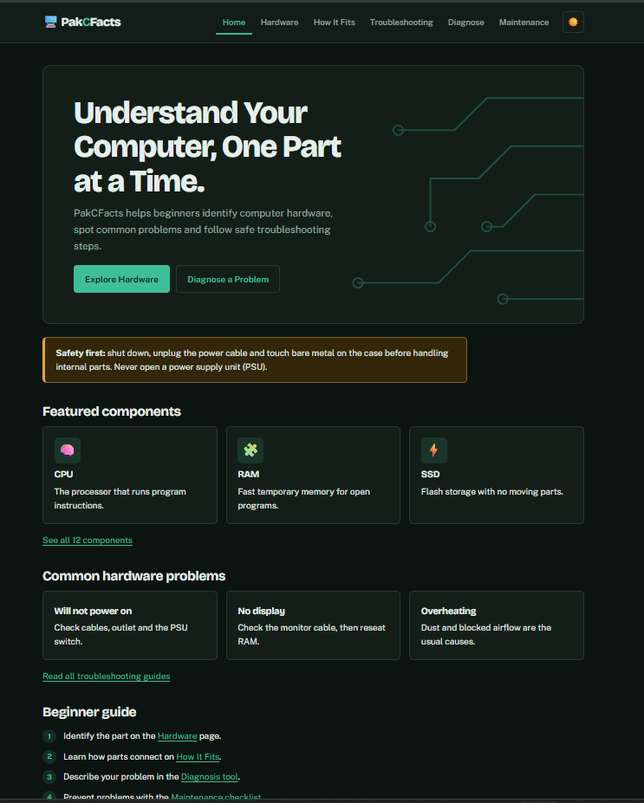
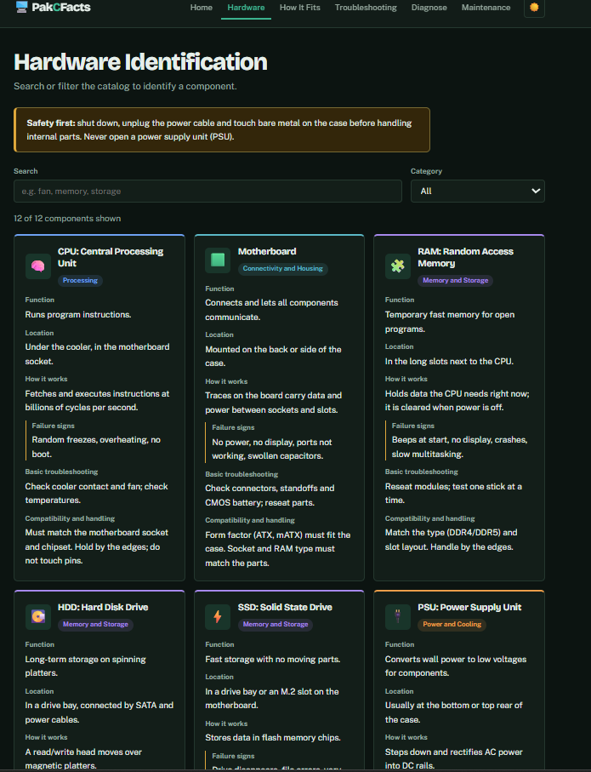
- Home page Hardware Identification

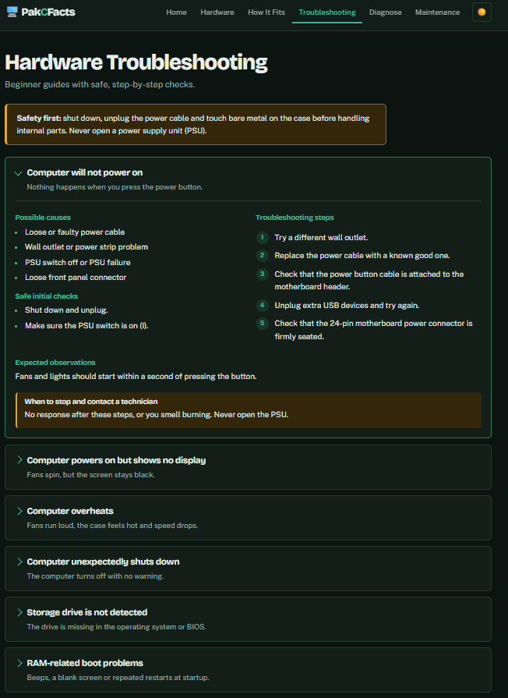
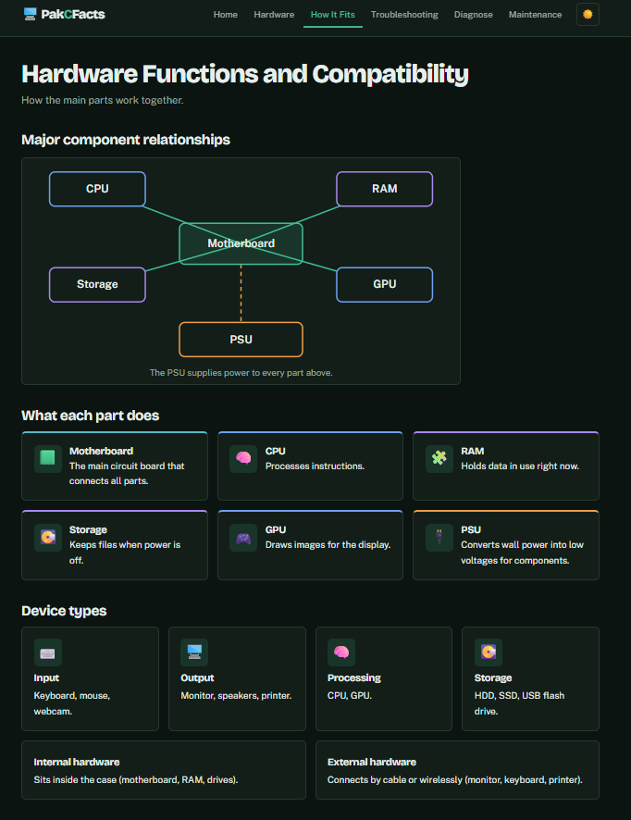
- Hardware Functions and Compatibility Hardware Troubleshooting

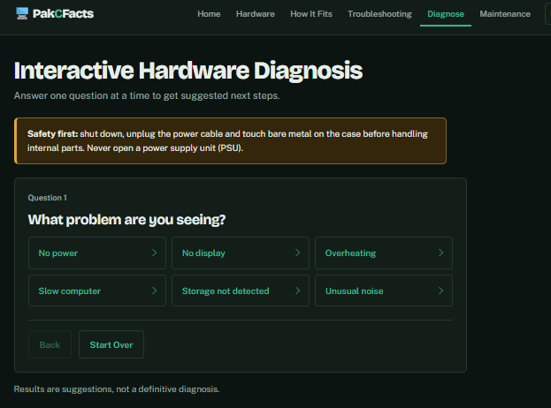
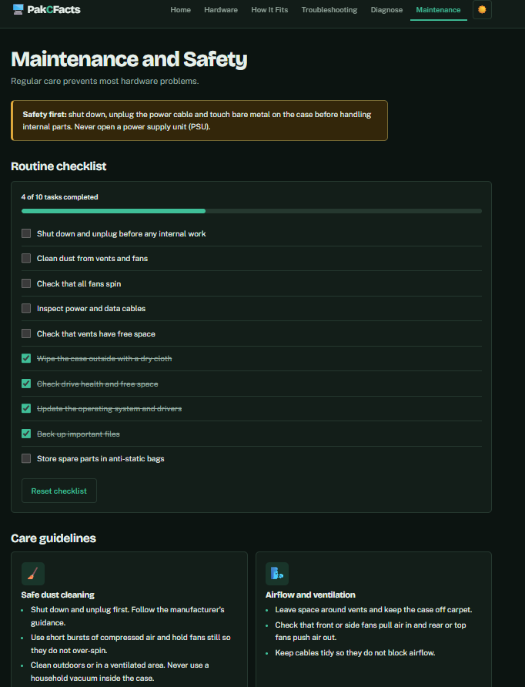
- Interactive Hardware Diagnosis Maintenance and Safet y

Appendix B — Source Code
https://github.com/Arnold-Gelacio/PakCFacts

References
Department of Education. (2016). K to 12 basic education curriculum: Junior high school technology and livelihood track and senior high school technical-vocational livelihood track: Information and communications technology—Computer Systems Servicing (NC II) (640 hours). https://www.deped.gov.ph/wp-content/uploads/2019/01/Computer-Systems-Servicing-NC-II-CG.pdf

Dev, N., & Anderson, B. (1997). Pimtool, an expert system to troubleshoot computer hardware failures. In Proceedings of the Ninth Conference on Innovative Applications of Artificial Intelligence (pp. 853–860). AAAI Press. https://cdn.aaai.org/IAAI/1997/IAAI97-181.pdf

IBM. (n.d.). Electrostatic discharge procedures. IBM Documentation. https://www.ibm.com/docs/en/ts7620-protectier/3.4?topic=components-electrostatic-discharge-procedures

MDN contributors. (n.d.). Media query fundamentals. MDN Web Docs. https://developer.mozilla.org/en-US/docs/Learn_web_development/Core/CSS_layout/Media_queries

Nielsen, J. (2024, January 30). 10 usability heuristics for user interface design. Nielsen Norman Group. https://www.nngroup.com/articles/ten-usability-heuristics/

Reed, N. E., & Johnson, P. E. (1993). Analysis of expert reasoning in hardware diagnosis. International Journal of Man-Machine Studies, 38(2), 251–280. https://doi.org/10.1006/imms.1993.1012

Supermicro. (2026, March 12). Static-sensitive devices. Supermicro User’s Manual. https://www.supermicro.com/en/support/manuals/product/motherboard/x14dbg-gd/Content/component-installation/static-sensitive-devices.htm

Technical Education and Skills Development Authority. (2013). Training regulations: Computer Systems Servicing NC II (amended December 2013). https://tesda.gov.ph/Downloadables/TRs/TR%20Computer%20Systems%20Servicing%20NC%20II%20.pdf

World Wide Web Consortium. (2024, December 12). Web Content Accessibility Guidelines (WCAG) 2.2. https://www.w3.org/TR/WCAG22/

